**IBM - Watson**

**And**

**GRAMMYS**

GRAMMY® Insights with IBM Watson uses the AI and natural language processing of Watson Discovery to analyze over 20 million news articles, blog posts and [GRAMMY.com](http://www.grammy.com/) sources, and turns them into bite-sized artist insights that will appear on the screen in real time.

In collaboration with the Recording Academy, IBM Consulting designed and developed GRAMMY® Insights with Watson to transform the GRAMMYs® fan experience across its digital platforms, driving more engagement and deepening the connection between music fans and the artists they love.

By automating the production of relevant content, this technology solution enables the Recording Academy editorial team to deliver a compelling digital experience quickly and efficiently.

 Using pre-built accelerators, analysis indicates that IBM was able to significantly speed the development process and build a smoother, more personalized experience for 22,000 existing members around the world.

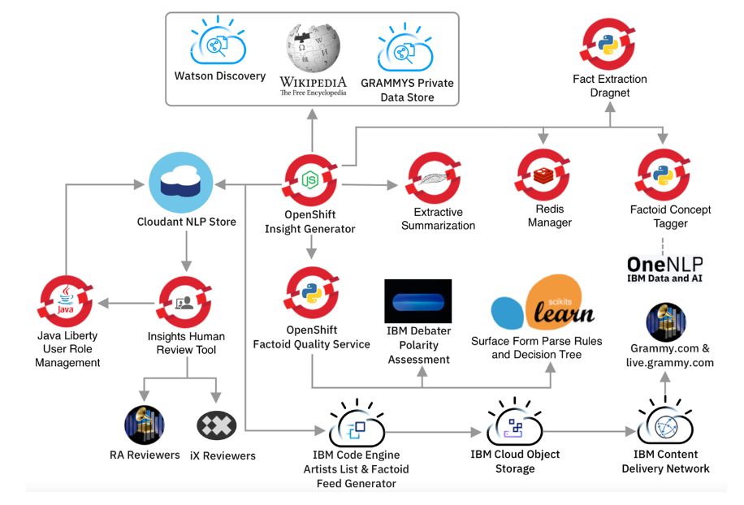

Figure 1. **The overall architecture of the Automated Intelligent Workflow system**

**Overall System Architecture**

IBM Consulting developed a system as described in Figure 1 that enables the Recording Academy to engage their fan base while also broadening their viewership through AI-powered insights. The workflow that we developed enhances the digital experience and encourages deeper fan engagement through consumer interfaces while also scaling the expertise of the Recording Academy’s editorial team.

To achieve both goals, the AI technology had to be capable of running anywhere on multiple clouds.

The first phase is the curation of insights. A corpus of information was generated from over 100,000 news sites, Wikipedia entries, custom content extraction based on Dragnet, and GRAMMY.com articles.

The Insight Generator, an event-driven Node.js application, was the broker for all messages and data flow. Redis was broadly used throughout the application to manage state at scale. Most of the internal processing is managed by [Bull](https://www.npmjs.com/package/bull), an open source, Redis-based queue manager that enabled us to maintain state persistence across several applications.